Team Kapu$niaki

Projekt Kapu$ta

2024-02-11

**POST /auth/register**

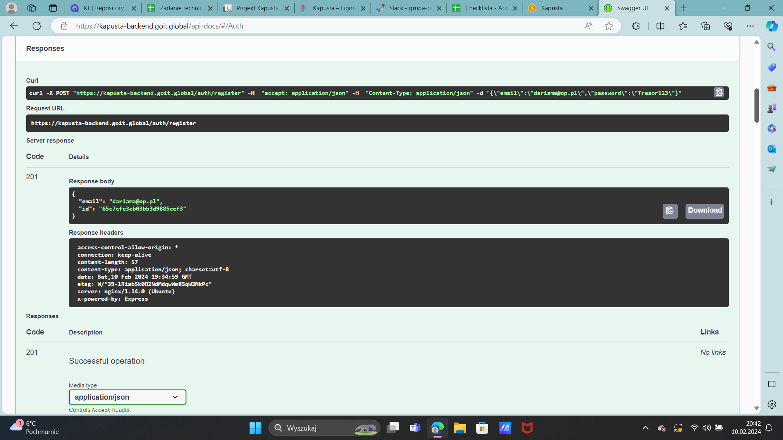

**POST /auth/login**

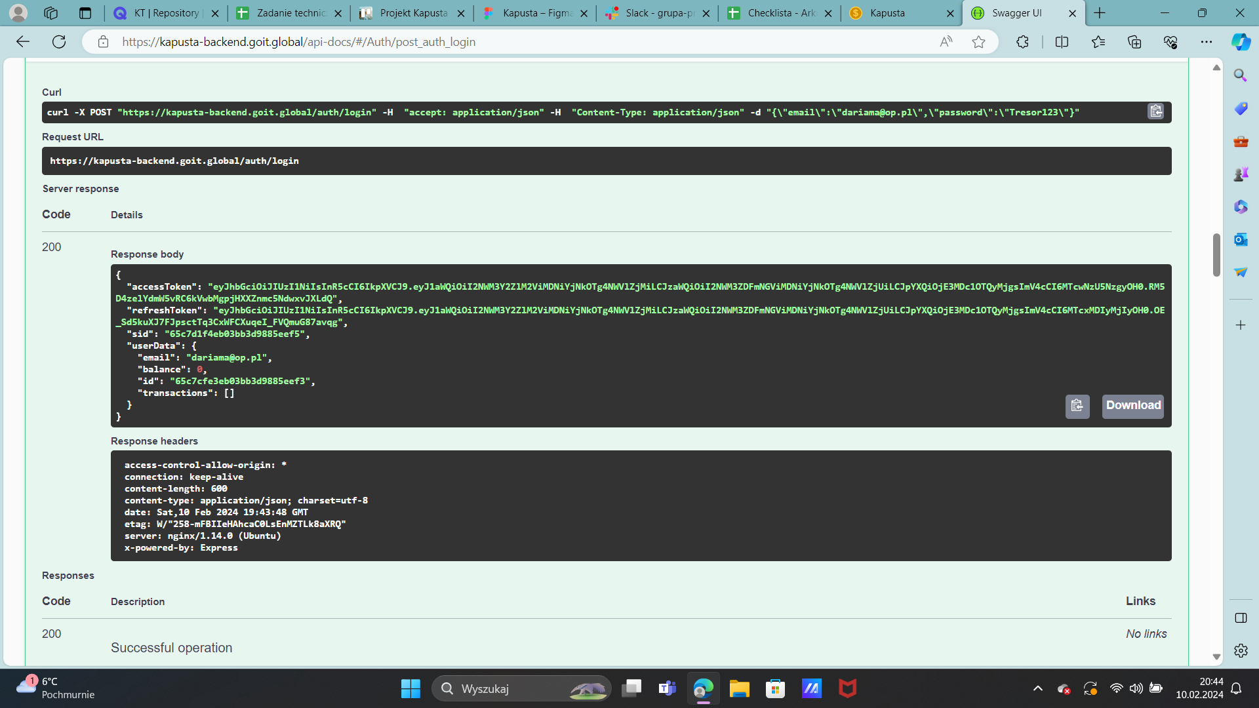

**POST /auth/logout**

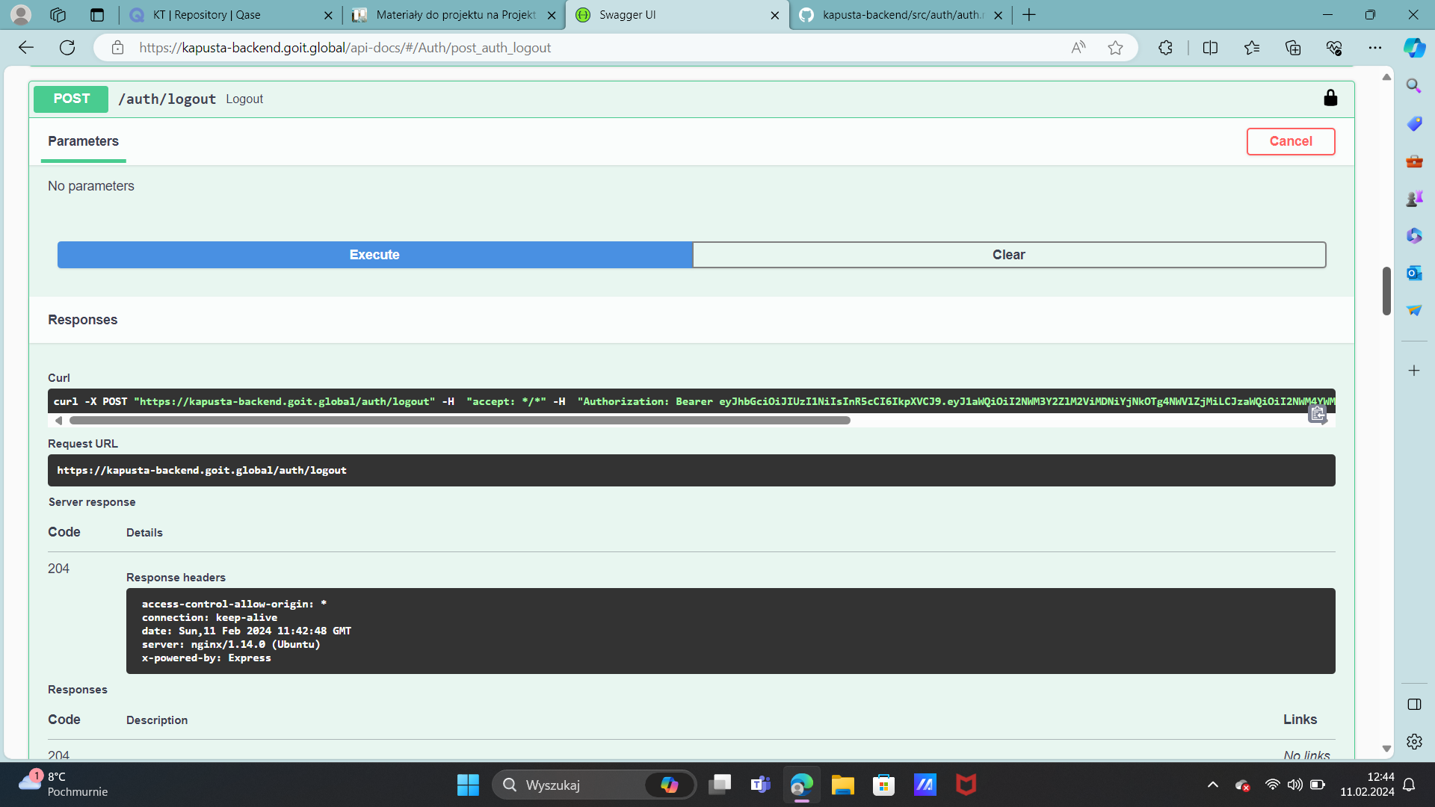

**POST /auth/refresh**

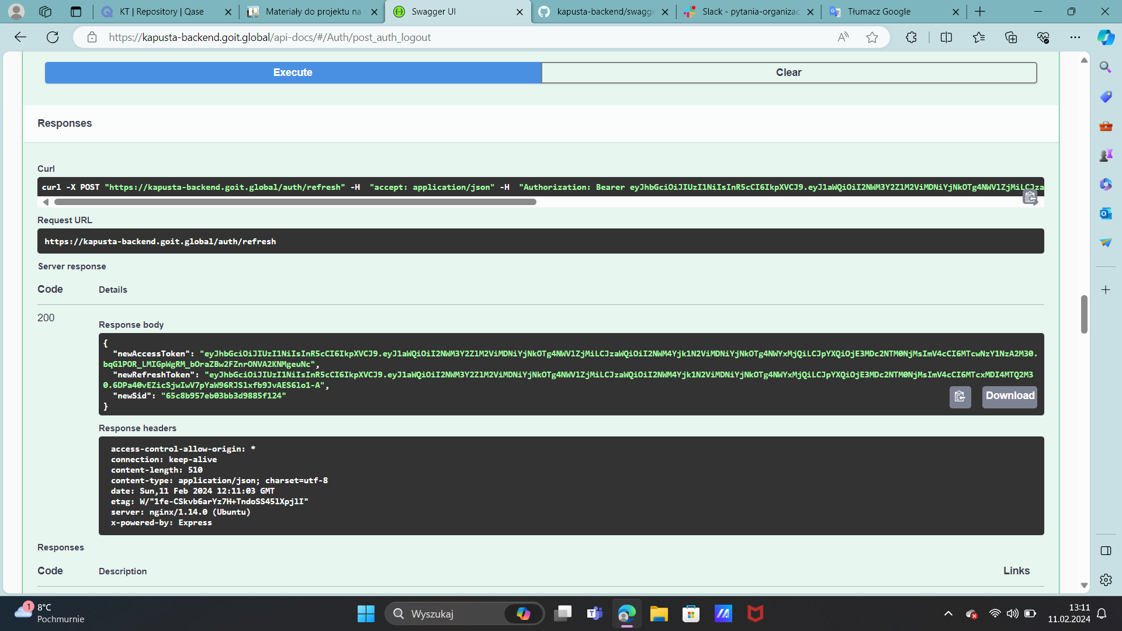

**GET /auth/google**

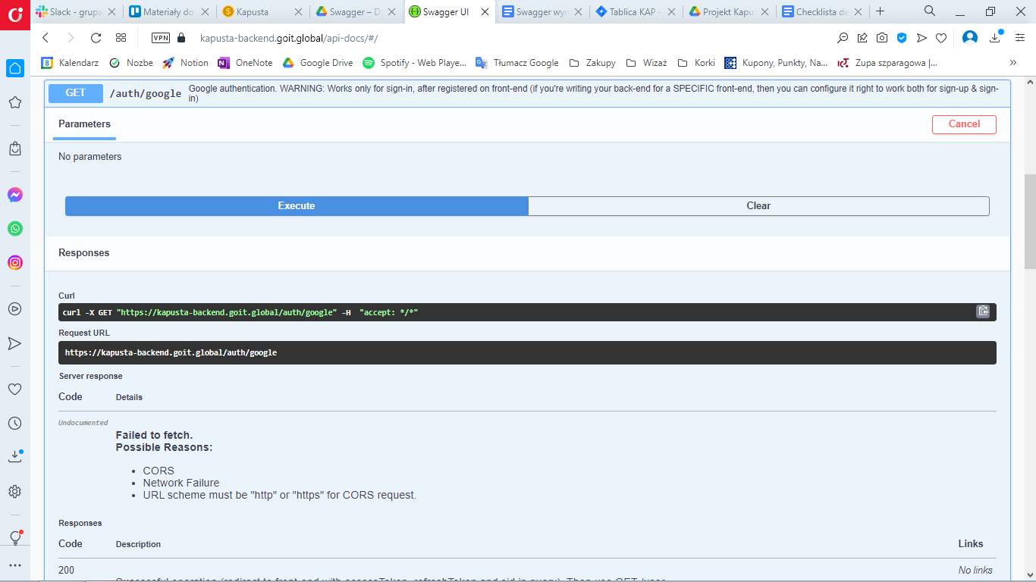

**POST /transaction/income** - add an income

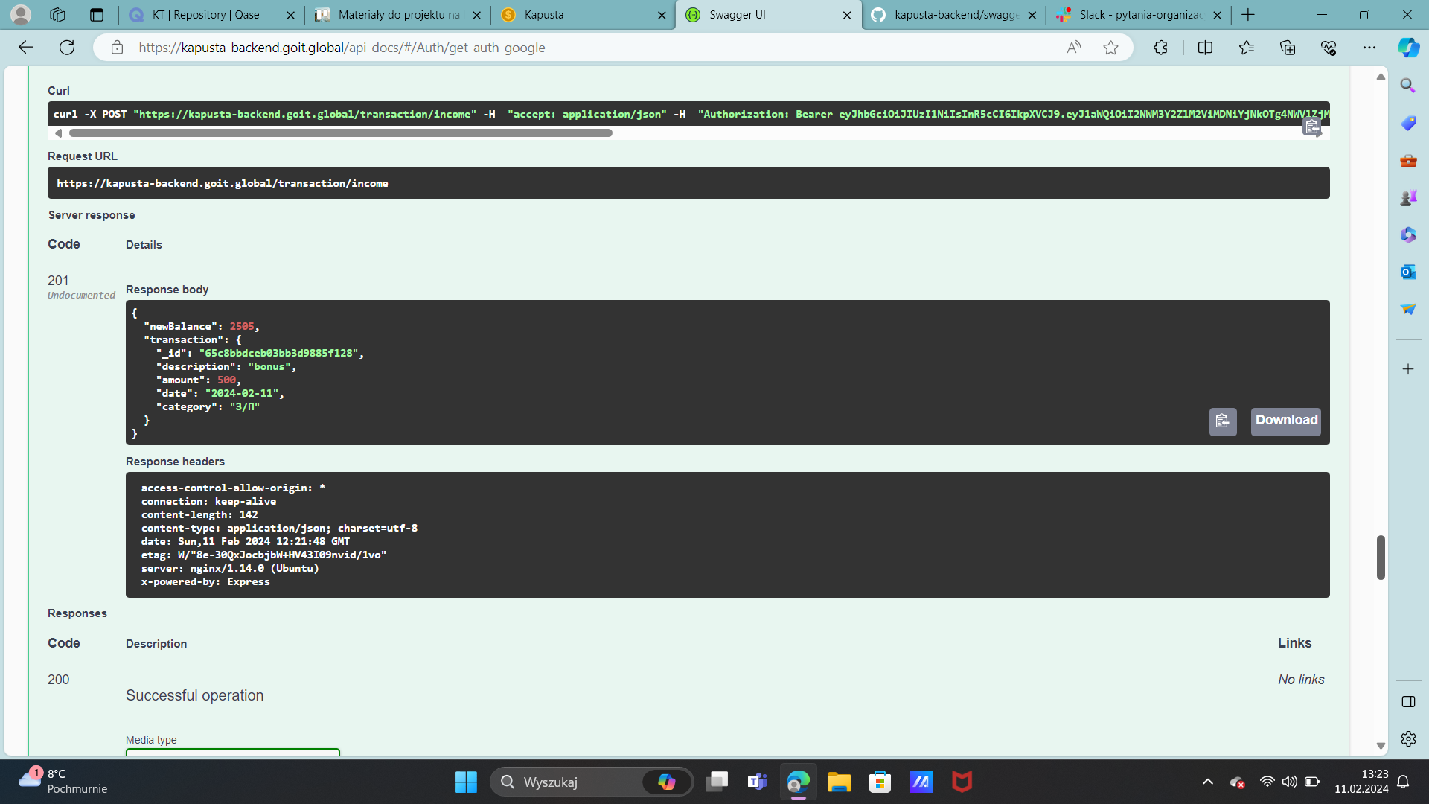

**GET /transaction/income** - get income stats

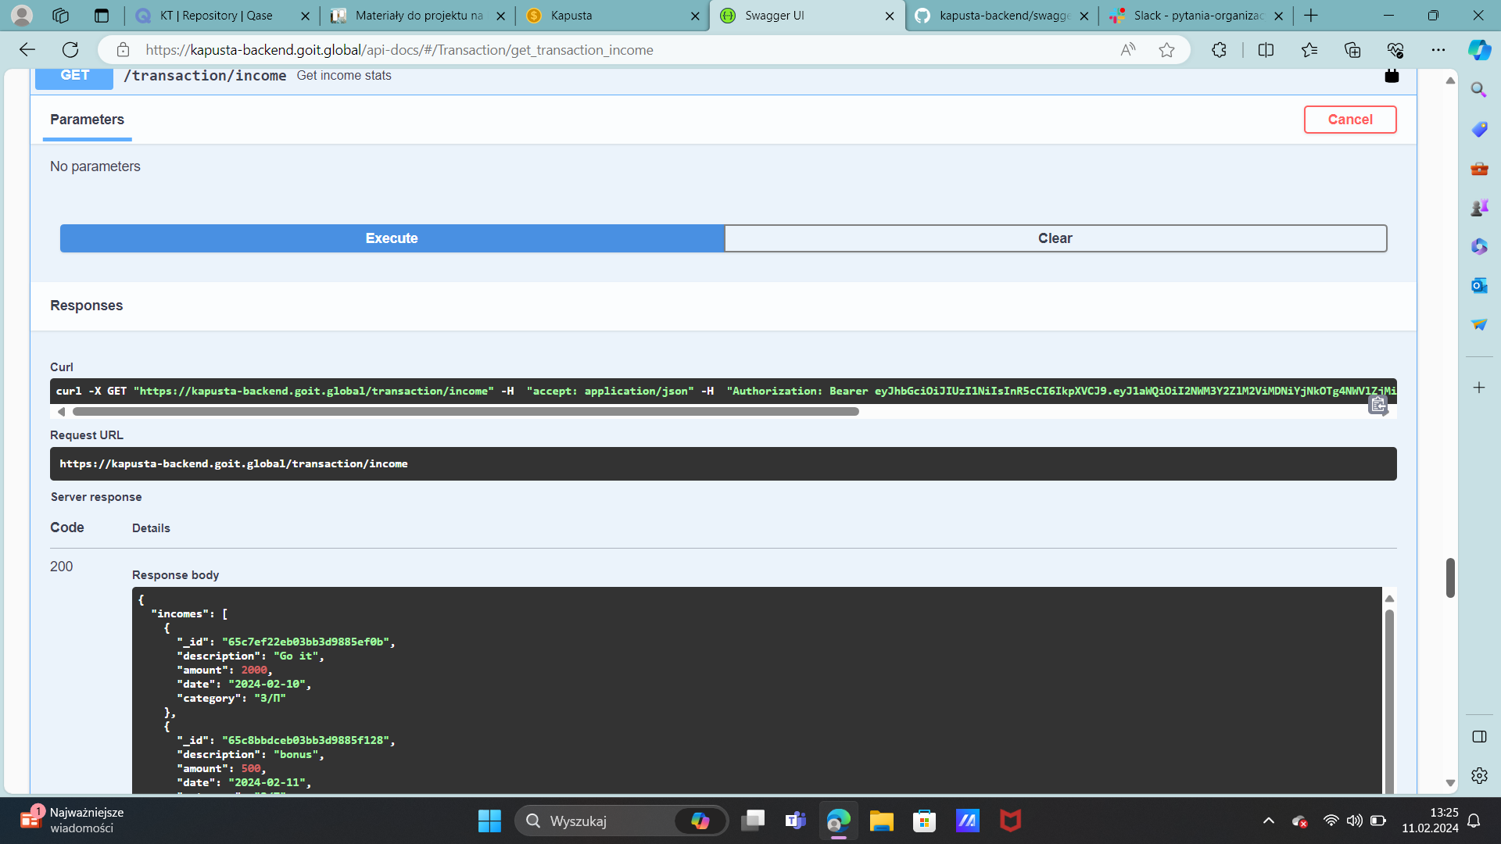

**POST /transaction/expense** - add an expense

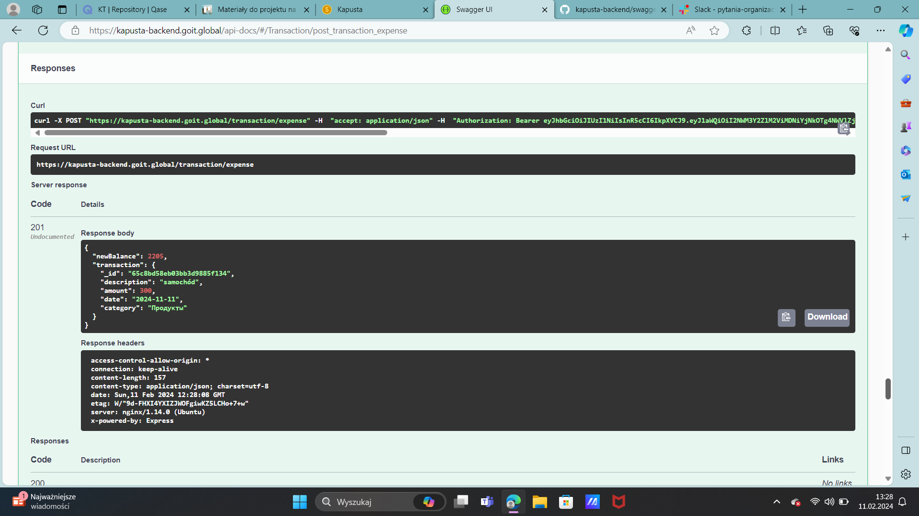

**GET /transaction/expense** - get expense stats

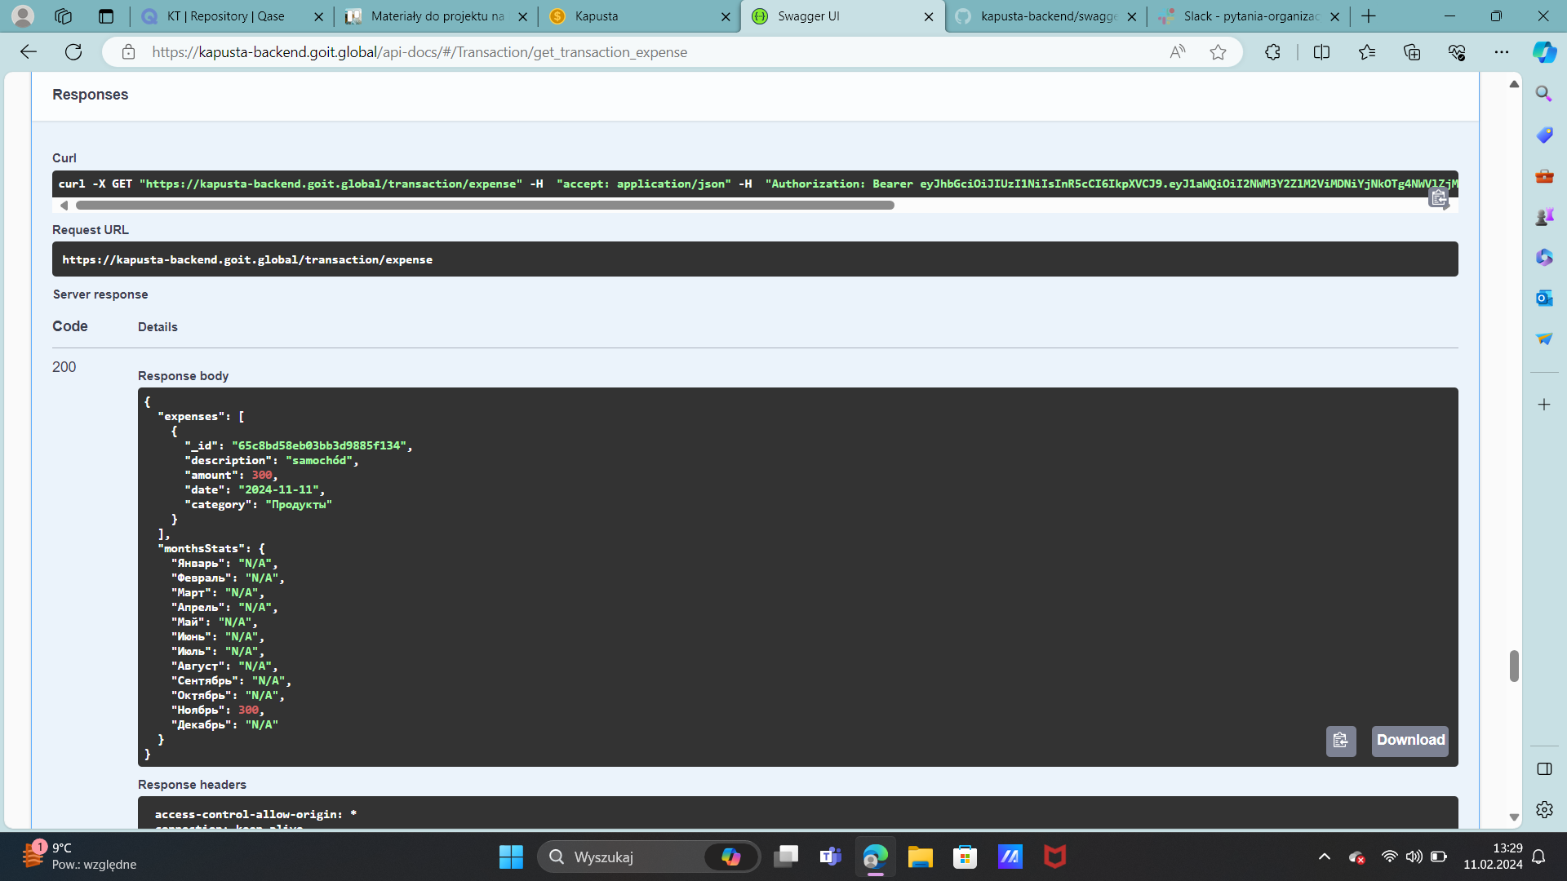

**DELETE /transaction** - delete transaction

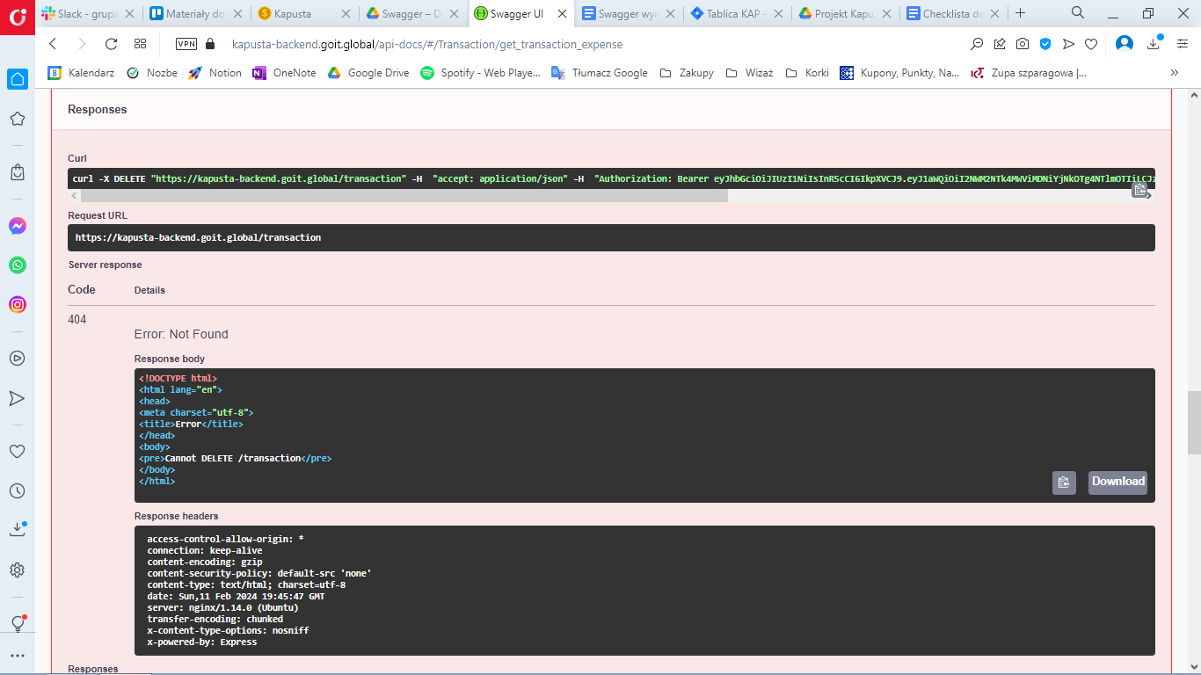

**GET /transaction/income-categories**

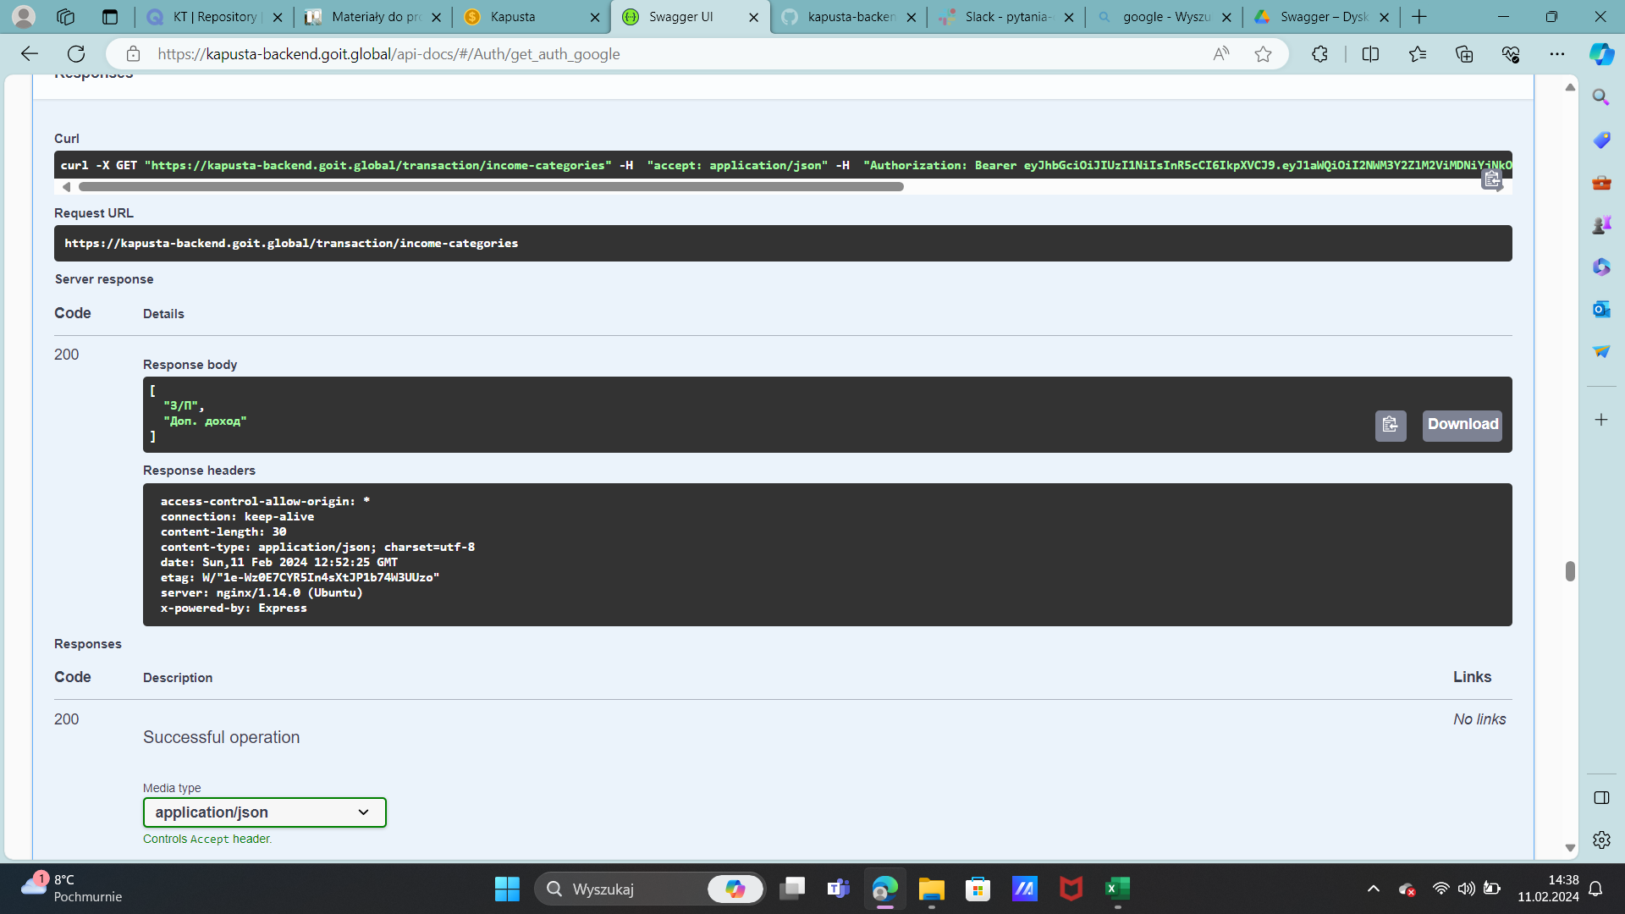

**GET /transaction/expense-categories**

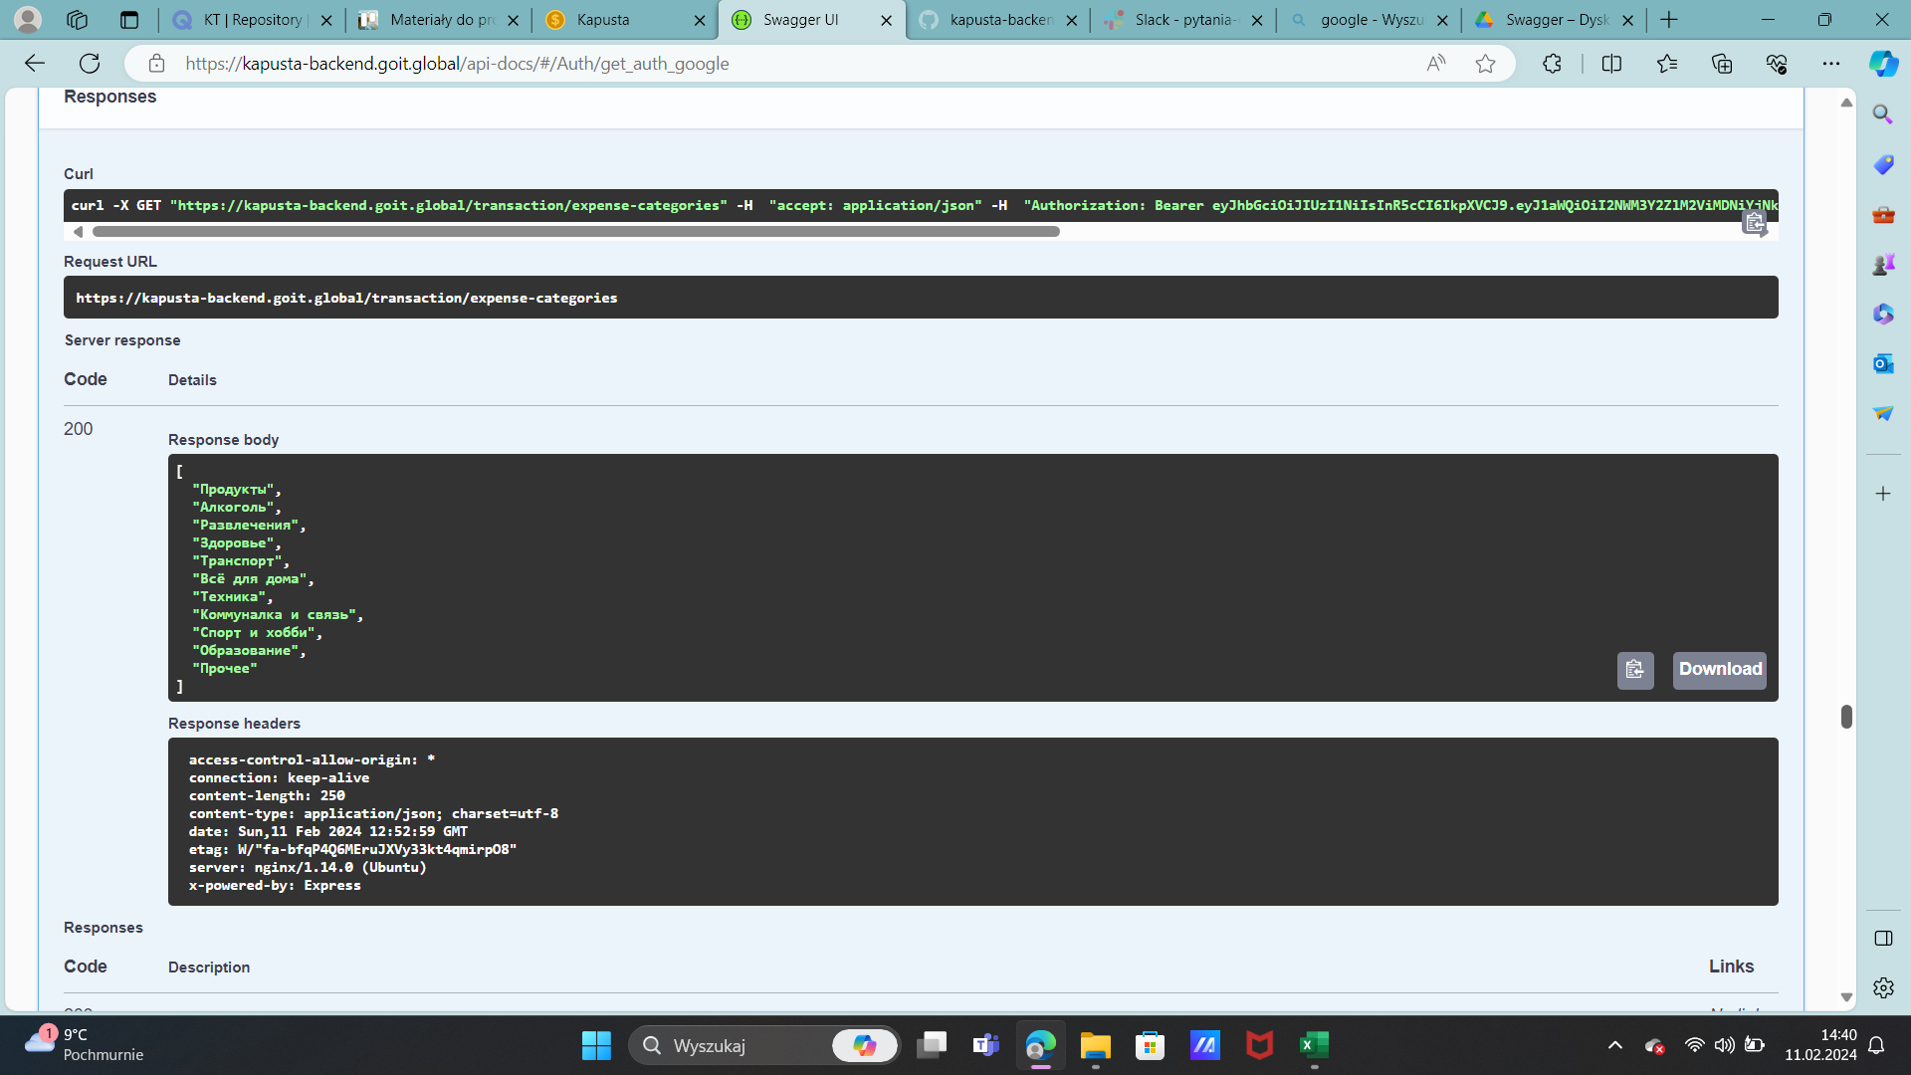

**GET /transaction/period-data**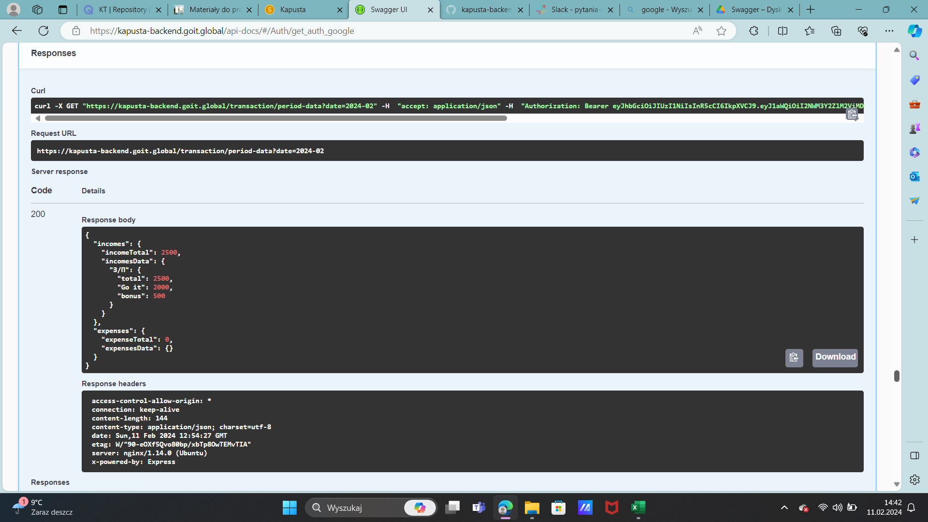

**PATCH /user/balance**

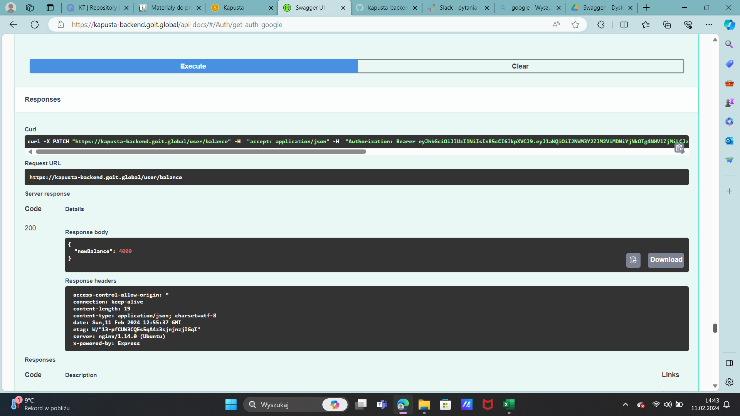

**GET /user**

